2015-SI-01-EN Inheritance Inheritance
0 ---- | I: hard | II: medium | III: easy | IV: ----

Answer Type: Multiple Choice Mandatory for: none

Body

Tony is the CEO of a small software company. He has three Executive Directors, Lucky, Al and Vito (from most experienced to least experienced respectively).

- Lucky has a team leader named Mickey. Mickey has two team members Alberto and Donnie.
- Al has a team leader named Frankie. Frankie has one team member named Vincenzo.
- Vito has two team members, Riccardo and Jack.

When a company member is absent, the next most experienced person takes the position.
All company members can be ordered by their experience as follows:
Tony → Lucky → Al → Vito
Mickey → Frankie → Riccardo → Jack
Alberto → Donnie → Vincenzo

The entire company is shown in the image.

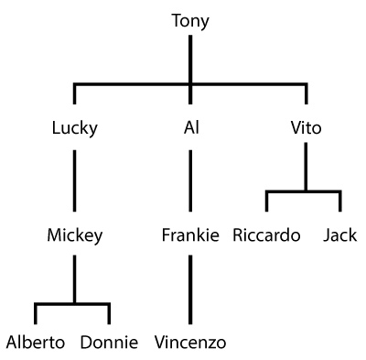

According to company rules, the most experienced worker inherits the leadership, when their superior is absent.

Question

The nature of the Tony's business is such that people often have business trips. How many people, including Tony, will have to leave for a business trip before Riccardo takes on the position of CEO?

Answer

A) 2
B) 6
C) 7
D) 9

The correct answer is B.

Explanation

When Tony is absent, Lucky becomes the CEO, and Mickey takes Lucky's position recursively (true for all members of Lucky's team).
Next, when Lucky is also absent, Al becomes the CEO, and his team members get promoted recursively.
When Al is also absent, Vito becomes the CEO, and his team members get promoted as well.
When Vito is also absent, Mickey becomes the CEO. When Mickey is also absent, Frankie becomes the CEO.
When Frankie is also absent, Riccardo becomes the CEO.

Therefore: Tony → Lucky → Al → Vito → Mickey → Frankie → Riccardo.
6 is the right answer.

It's informatics

The image shows a data structure called “tree”. Trees are used in many areas of computer science, from data storage to decision making systems. One of the common operations on trees is traversing them, that is, systematically exploring (printing, checking...) their contents. The two usual ways of doing this is breadth-first (Tony, Lucky, Al, Vito, Mickey...) and depth-first (Tony, Lucky, Micky, Alberto, Donnie...).

The company rules in this task follow the breadth-first principle.

Keywords

Tree traversal, breadth-first, bfs

Websites

https://en.wikipedia.org/wiki/Breadth-first_search

Internal Use

Wording

Comments

We have made it a company instead of la familia, and company rules are changed a bit. Therefore, it becomes breadth-first instead of depth-first.

Graphics

Illustrations are provided by the author (JD).

Files

All additional files for this task (graphics, scripts, etc.)
2015-SI-01-EN Inheritance.odt (this file)
bosses.svg, bosses.ai, bosses.png (image)

Authorship

Anže Starič, Slovenia
Janez Demšar; janez.demsar@fri.uni-lj.si, Slovenia
Edited by Rashad Aliyev (Azerbaijan), gmanras@gmail.com, and Filiz Kalelioglu (Turkey), filizk@baskent.edu.tr
Sarah Hobson, sarah.hobson@goodnews.qld.edu.au, Australia, 2015-05-27, edited for English grammar and phrasing.
Christian Datzko, christian@datzko.ch, Switzerland

License

Copyright © 2014 Bebras – International Contest on Informatics and Computer Fluency. This work is licensed under a Creative Commons Attribution-NonCommercial-ShareAlike 3.0 Unported License (CC BY-NC-SA 3.0). Visit: http://creativecommons.org/licenses/by-sa-sa/3.0/

